Session 3 – Hunger Scale
(handout 1)

Use this scale to identify your hunger level when you eat/think about eating.
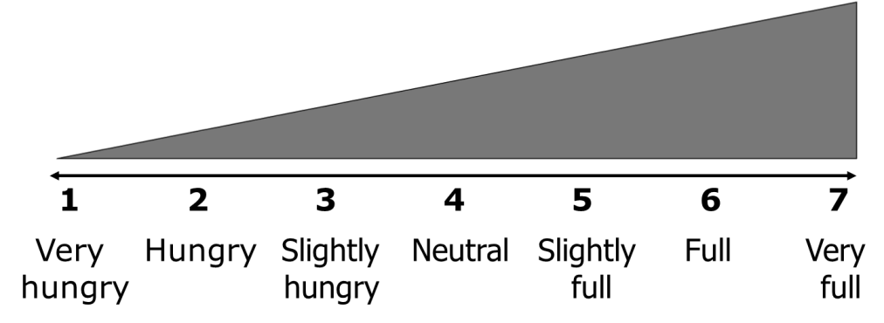

What do the numbers mean?
Number | Descriptor | Definition
1 | Very Hungry | You have either ignored your hunger for a long time or been unable to eat for some reason. You are beyond hungry and will likely overeat when food is available.
2 | Hungry | This is a good time to eat.
3 | Slightly Hungry | Slightly hungry. You can wait to eat but know that you will soon be hungry.
4 | Neutral | You are neither hungry nor full.
5 | Slightly Full | You sense food in your stomach and know that you will soon be full.
6 | Full | Your hunger is gone, but you are not uncomfortable.
7 | Very Full | You are uncomfortable. Think of how you may feel after overeating  Thanksgiving dinner or at an all-you-can-eat buffet.

