Session 1 - Balance Your Time
(handout 2)
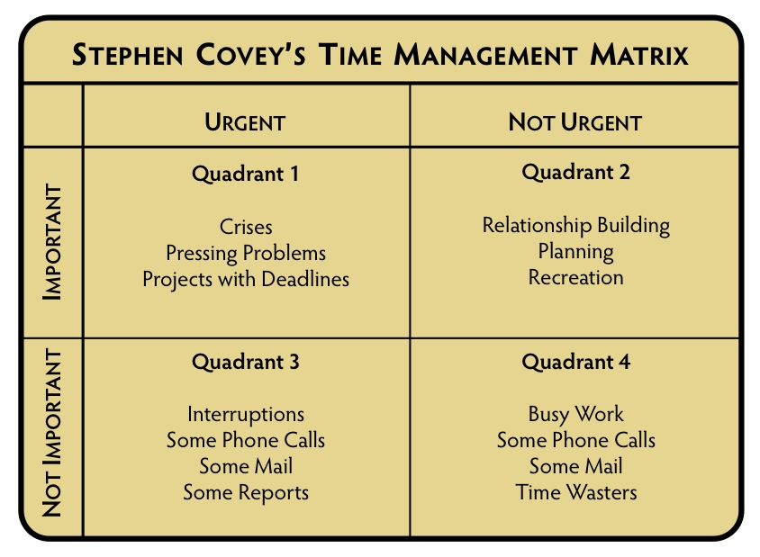
We live in a time pressured world where it is common to have multiple commitments that require immediate attention now. Urgency is no longer reserved for special occasions, it is everyday occurrence. How can one manage the ﬂood of responsibilities, do excellent work, reach goals and maintain a positive frame of mind? The Covey time management grid is an effective method of organizing your priorities.
source: Stephen Covey, 7 Habits of Highly Effective People
Quadrant I is for the immediate and important deadlines.
Quadrant II is for long-term strategizing and development.
Quadrant III is for time pressured distractions. They are not really important, but someone wants it now.
Quadrant IV is for those activities that yield little is any value. These are activities that are often used for taking a break from time pressured and important activities.
The Bottom Line: Do Important things First!
Using the worksheet below, take your current ‘to-do’ list and sort all the activities into the appropriate grid. Then, assess the amount of time you have to accomplish the lists and, if necessary, reallocate activities.
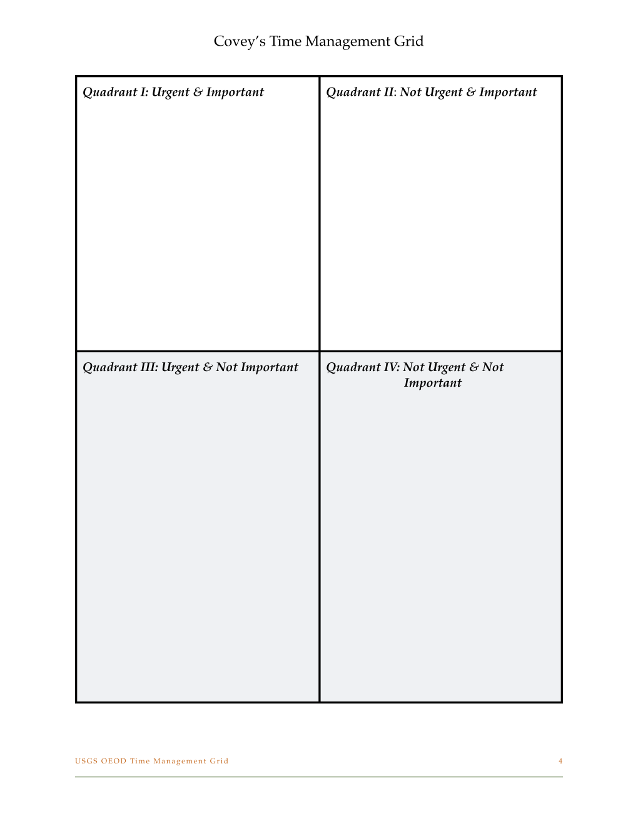
Covey’s Time Management Matrix

